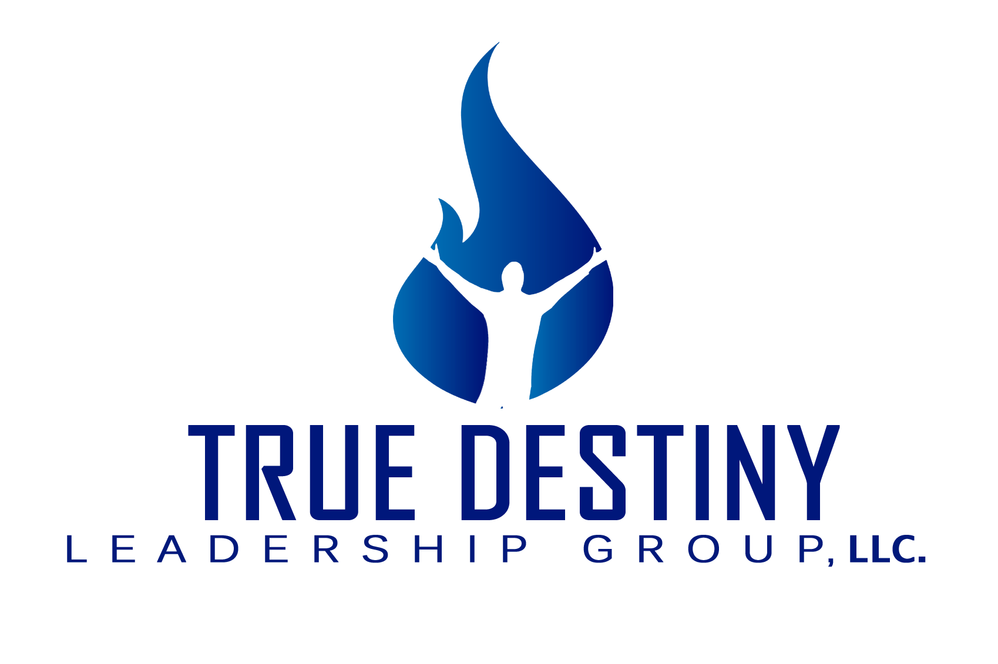 About the Company

True Destiny Leadership Group is a performance enhancement and training company, specializing in organizational leadership and personal development. Our network of trainers and facilitators is comprised of a talented group of enthusiastic and knowledgeable professionals who are dedicated to obtaining the best possible results for every client. Our skill base extends itself in the areas of seminars, workshops, retreats, and training programs. We also customize motivational keynote talks, which have proven to be a valuable tool in galvanizing and mobilizing a staff behind the mission and vision of its leader.

The uniqueness of our approach has been our ability to connect with the “person” not simply the “employee”. We believe that the best way to prepare people to meet the challenges of leadership and the demands of the workplace is to utilize the approach that brings about first attitudinal and subsequently, behavioral change. The programs, assessments and services delivered through TDLG provide a medium that helps people to realize more of their potential by better understanding themselves and thereby increasing their contribution to their organization.

The philosophy of True Destiny Communications is based upon the premise that men and women possess a virtually unlimited potential for achieving whatever they choose to accomplish. Their only real limitations are self-imposed. Our programs inform, educate, inspire and motivate the individual to look beyond conditions and focus on desired results. Experience tells us that as individuals are guided through the process of discovering the values of personal responsibility, self-motivation and synergistic effort, their levels of success, both personally and professionally, grow exponentially.

We recognize that each workplace has its own set of priorities, mission, vision and values. However, there is a single consistent element that exists in every organization; and that’s - people. It has been said “people are the problem – but people are also the solution”. Our focus is to assist in the process of building better people; because in the end, its better people, that makes better organizations.

